**CSC 1101 – Problem Solving and Programming Laboratory**

**Lab 2 – Trevor Trusty**

**25 points – Due January 21, 11pm**

**a)** Save this document with your name and the homework number somewhere in the file name.

**b)** Type/paste your answers into the document.

**c)** Submit this document and your .cpp file(s) to the Canvas item where you downloaded this document. Do not submit a zip file but individually attach your files.

You will write three programs in this lab. If using Visual Studio, you may use one Visual C++ CLR console application and switch among your three C++ .cpp files, or create one Visual C++ CLR console application for each program.

**1) [8 points]** You've been hired by *Lyric Lovers* to write a C++ console application that displays lyrics from the song *Climb Every Mountain* from The Sound of Music. Start with file **Lab02-01.cpp**. Complete the header comment. Write **cout** statements to display the lyrics as shown here. Use keyword **endl** to include blank lines between paragraphs.

*[your program code here]\**

**//==========================================================**

**//**

**// Title: Lyric Viewer**

**// Course: CSC 1101**

**// Lab Number: Lab 2**

**// Author: Trevor Trusty**

**// Date: 1/17/2019**

**// Description:**

**// Application that displays lyrics for the song Climb Every Mountain on a console window.**

**//**

**//==========================================================**

**#include <conio.h> // For function getch()**

**#include <cstdlib> // For several general-purpose functions**

**#include <fstream> // For file handling**

**#include <iomanip> // For formatted output**

**#include <iostream> // For cin, cout, and system**

**#include <string> // For string data type**

**using namespace std; // So "std::cout" may be abbreviated to "cout"**

**int main()**

**{**

**// Show application header**

**cout << "Welcome to Lyric Lovers" << endl;**

**cout << "-----------------------" << endl << endl;**

**// Show lyrics**

**//Text-Block 1**

**cout << "Climb every mountain," << endl;**

**cout << "Search high and low," << endl;**

**cout << "Follow every byway," << endl;**

**cout << "Every path you know." << endl << endl;**

**//Text-Block 2**

**cout << "Climb every mountain," << endl;**

**cout << "Ford every stream," << endl;**

**cout << "Follow every rainbow," << endl;**

**cout << "'Till you find your dream." << endl << endl;**

**//Text-Block 3**

**cout << "A dream that will need" << endl;**

**cout << "All the love you can give," << endl;**

**cout << "Every day of your life" << endl;**

**cout << "For as long as you live." << endl;**

**// Show application close**

**cout << "\nEnd of Lyric Lovers" << endl << endl;**

**// Pause before application window closes**

**cout << "Press any key to exit ..." << endl;**

**_getch();**

**}**

*[your program output here]\*\**

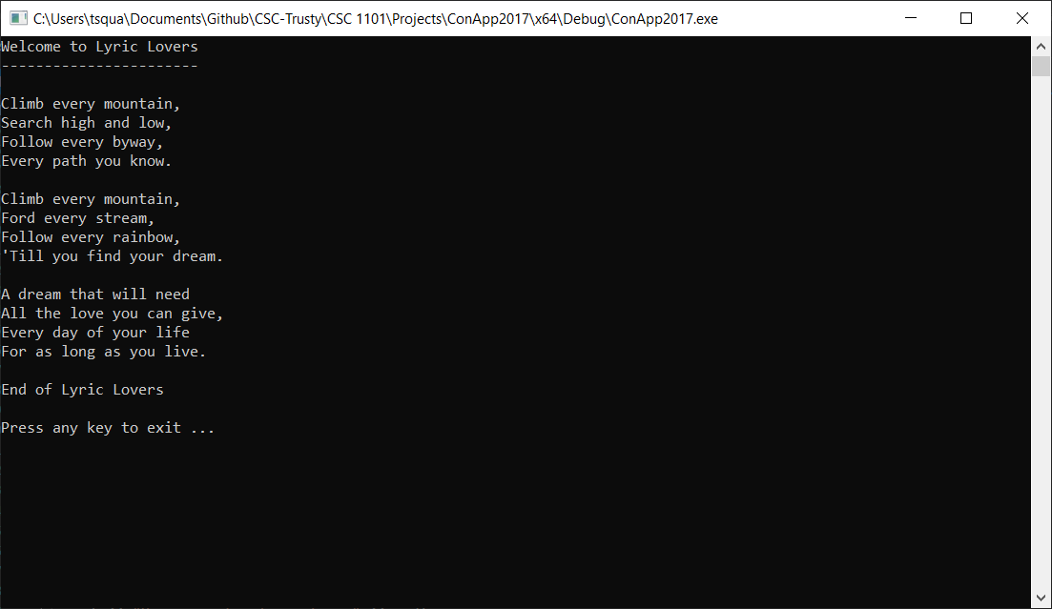

**2) [8 points]** You've been hired by *Square and Cube, Inc* to modify a C++ console application that calculates the square and cube of a number. Start with file **Lab02-02. cpp** and make the following edits:

1) Complete the header comment.

2) Declare integer variable *num*with an initial value of 4.

3) Modify the application header and close to contain the application name.

4) Run the program.

What is the square of 4? ___16_______

What is the cube of 4? ____64______

5) Run the program three more times with different values for variable *num*. What are the results?

|  |  |  |  |
| --- | --- | --- | --- |
| Run | num | Square | Cube |
| 1 | 8 | 64 | 512 |
| 2 | 2 | 4 | 8 |
| 3 | 7 | 49 | 343 |

*[your program code here]\**

**//==========================================================**

**//**

**// Title: Square and Cube of 7**

**// Course: CSC 1101**

**// Lab Number: 2-2**

**// Author: Trevor Trusty**

**// Date: 1/17/2019**

**// Description:**

**// This console application takes the number 7,**

**// and calculates the value to the second and third powers and**

**// displays them for the user.**

**//**

**//==========================================================**

**#include <conio.h> // For function getch()**

**#include <cstdlib> // For several general-purpose functions**

**#include <fstream> // For file handling**

**#include <iomanip> // For formatted output**

**#include <iostream> // For cin, cout, and system**

**#include <string> // For string data type**

**using namespace std; // So "std::cout" may be abbreviated to "cout"**

**int main()**

**{**

**// Declare variables**

**int num = 7;**

**// Show application header**

**cout << "Welcome to Square and Cube of " << num << endl;**

**cout << "--------------------------" << endl << endl;**

**// Calculate and show square and cube**

**cout << "For number " << num**

**<< ", the square is " << num * num**

**<< ", and the cube is " << num * num * num**

**<< "." << endl;**

**// Show application close**

**cout << "\nEnd of Square and Cube of " << num << endl << endl;**

**// Pause before application window closes**

**cout << "Press any key to exit ..." << endl;**

**_getch();**

**}**

*[your program output here]\*\**

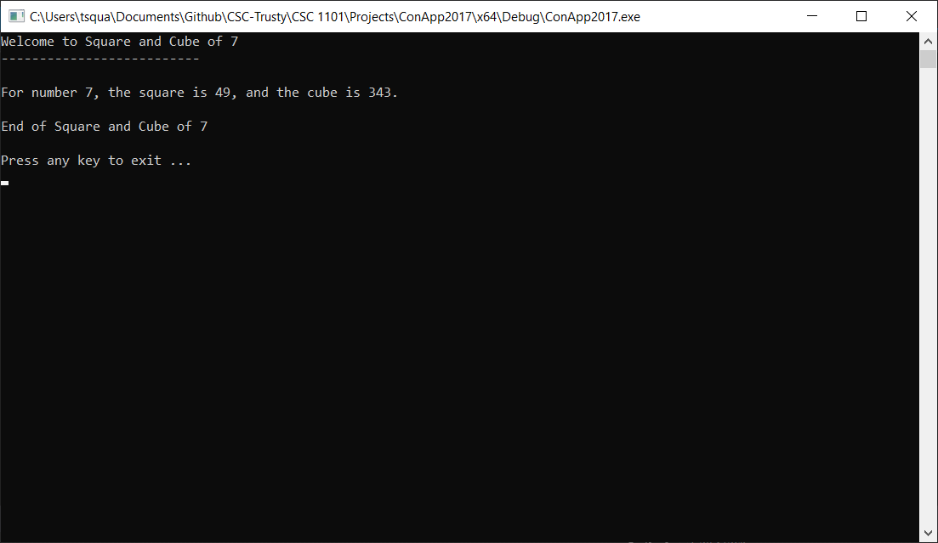

**3) [9 points]** You've been hired by *Winter Wonders* to write a C++ console application that calculates total and average snowfall. Start with file **Lab02-03.cpp**:

1) Complete the header comment.

2) Declare five variables:

● Integers (type int) *month1*, *month2*, and *month3* with initial values 2, 6, and 5, respectively.

● Reals (type double) *total* (inches), and *average* (inches/month).

3) Add an application header using cout statements.

4) Add an application close using a cout statement.

5) Run the program.

What is the total snowfall (inches)? _13_____

What is the average snowfall (inches/month)? ___4.33333_______

6) Run the program three more times with different values for the three months. What are the results?

|  |  |  |  |  |  |
| --- | --- | --- | --- | --- | --- |
| Run | Month 1 | Month 2 | Month 3 | Total snowfall | Average snowfall |
| 1 | 3 | 7 | 9 | 19 | 6.33333 |
| 2 | 12 | 1 | 8 | 21 | 7 |
| 3 | 0 | 10 | 11 | 21 | 7 |

*[your program code here]\**

**//==========================================================**

**//**

**// Title: Three Month Snowfall**

**// Course: CSC 1101**

**// Lab Number: 2-3**

**// Author: Trevor Trusty**

**// Date: 1/17/2019**

**// Description:**

**// Console application that writes the total and average snowfall amounts in inches over three months to the user.**

**//**

**//==========================================================**

**#include <conio.h> // For function getch()**

**#include <cstdlib> // For several general-purpose functions**

**#include <fstream> // For file handling**

**#include <iomanip> // For formatted output**

**#include <iostream> // For cin, cout, and system**

**#include <string> // For string data type**

**using namespace std; // So "std::cout" may be abbreviated to "cout"**

**int main()**

**{**

**// Declare variables**

**int month1 = 0;**

**int month2 = 10;**

**int month3 = 11;**

**double total;**

**double average;**

**// Show application header**

**cout << "Welcome to ###" << endl;**

**cout << "-------------------------------" << endl;**

**// Calculate total and average**

**total = month1 + month2 + month3;**

**average = total / 3;**

**// Calculate and show inputs and outputs**

**cout << "Snowfall amounts" << endl;**

**cout << "Month 1 (inches): " << month1 << endl;**

**cout << "Month 2 (inches): " << month2 << endl;**

**cout << "Month 3 (inches): " << month3 << endl;**

**cout << "Total (inches): " << total << endl;**

**cout << "Average (inches/month): " << average << endl;**

**// Show application close**

**// <your code here>**

**// Pause before application window closes**

**cout << "Press any key to exit ..." << endl;**

**_getch();**

**}**

*[your program output here]\*\**

